Adapted from the ASG FAQ and related resources
Contents
1. Table of Sampling Categories 2
2. Sampling Protocols 3
2.1. Before field 3
2.2. In field 4
2.2.1. Important considerations 4-5
2.2.2. Sampling & storage – Reference Genome 5
2.2.3. Sampling & storage – Water Samples 6-7
2.2.4. Sampling & storage – Whole Genome Sequencing 8
2.2.5. Sampling & storage – RNA Sequencing 8

3. Shipping Instructions 9
4. Acid Wash Protocol 10
5. Parts list 11
Appendix: What if …? 12

1. TABLE OF SAMPLING CATEGORIES
Sample type | Preservative  (& storage) | Number of specimens/species | Number of replicates/specimen | Shipping Destination (temperature)
Tissues for reference genomes of host & symbionts | Liquid Nitrogen preferred, dry ice acceptable  (-80 C freezer) | 1 (or 2) | 8-10 (or 4 minimum) | Sanger via biocare (on dry ice)
Tissues for RNA sequencing of host & symbionts | RNA Later  (refrigerator for 24 hrs, then -15C freezer) | 8 | 0, no replicates needed (except MND sample multiple body parts) | UC Merced (ambient ºC)
Tissues for whole genome sequencing (WGS) of non-reference host & symbionts | DMSO-NaCl  (-15C freezer) | 8 | 0, no replicates needed (except MND sample multiple body parts) | UC Merced (ambient ºC)
Host-associated mucus-water for microbial reference | RNA later  (refrigerator for 24 hrs, then -15C freezer) | 4 | 0 | UC Merced (ambient ºC)
‘Clear water’ for reference microbial diversity | RNA later  (refrigerator for 24 hrs, then -15C freezer) | 4 samples (from water around, but without, the jellies) | 0 | UC Merced (ambient ºC)
Voucher specimen | 4% formalin  photograph | 1 | none required, 1-2 could be helpful | home institution or UC Merced (ambient ºC)

2. SAMPLING PROTOCOLS
2.1. BEFORE going in the field
Permitting
You will need to have initiated various processes by completing the collaborator onboarding form, uploading your manifest into COPO (https://copo-project.org/), and submitting permit applications, and to be in contact with relevant partners to ensure compliance with the Nagoya protocol. You’ll need to coordinate with ASG complete an IV58 for shipping to UK, and to get Mike to complete the eDec form for importing into the US.
Then you can …
… locate resources needed for preservation (see mailed kits):
* = item will be sent to you
- Reference genome
  - liquid Nitrogen (LN2) [alternative: dry ice]
  - 10 barcoded FluidX tubes *
- RNA sequencing
  - 2ml tubes of RNAlater *
[alternatives: LN2, dry ice]
- Whole genome sequencing
  - 2 ml tubes of DMSO+NaCl
[alternatives: 100% EtOH, LN2, dry ice]
- Voucher specimens = 4-10% Formalin (in sea water), 70% ethanol per your taxon’s standards.
… locate items needed for sampling, storage, and shipping (see mailed kits):
- Tissue collections
– pre-labelled 2 ml tubes *
– collection sheet*
– dewar for LN2 / insulated containers for dry ice (reference genome samples) & -80C freezer
– box / package for shipping *
– tools for collection and live storage including Nansen bottle or equivalent, baggies, etc
– dissecting kit, cleaning supplies
Forceps, gloves, scissors*
– gps, camera, fieldnotes
– sample manifest
– mandatory metadata form (see manifest columns)
- Water collections
  - 47mm filters *
  - 47mm filter chambers *
  - Syringe *
  - 2ml tubes RNA later (for ‘clear’ water reference, mucus reference) *
  - Ziplock bag*
2.2. In the Field
2.2.1. Important considerations
Collection:
– Microbiomes and RNA may differ by age (size) and historical and contemporary environments of the host, so first aim for replication of a single stage (preferably medusa or equivalent) and tissue type (see below), and second, with a couple of remaining tubes, aim for specimens across a range of sizes; environments; life history stages (e.g. egg, larva, polyp, strobila, juvenile, mature medusa (both sexes); etc
– The primary sample will usually include both host+symbiont; supplementary samples may include host+symbiont or only host if it is a nonsymbiotic life history stage
– Samples should be of diploid tissue unless specifically targeting gametes or gonads for RNA analyses
– Tissues sampled should be rich in cellular material, e.g. muscle bands, tentacles, mouths on the oral arms of rhizostomes, avoid gut unless starved for 12 hours, if possible avoid pigmented tissues
– each tissue sample should be small (~0.1-0.2 ml [approx a decent sized lentil]), in its own tube, with replicates
– mucus-water samples should be taken from a subset of half of the specimens
– water samples, in quadruplicate, should be taken with each set of specimens
– Do not clean/wash specimen as we are also interested in the microbiome
Taxa specific considerations:
- Salps – sample the animal itself not any mucus etc.
- Hydrozoa - tentacle
- Medusae – rhizostome and semaeostomeae oral arm
- Flatworms – whole specimen
- Ctenophores – 8ml tubes, take as much tissue as possible
- Cydippid ctenophore – long tentacle
- Acoels (tiny) - Sample some specimens on their own, then fill few tubes with multiple (count how many) specimens.
Specimen identification:
– The genome sequences will stand as references for the nominal species, so please ensure identifications are correct, samples are taken for barcoding, and a voucher specimen is deposited, and specimens are photographed informatively.
Sample amount
– each sample should be small (~0.1-0.2 ml) and in its own tube
2.2.2. Sampling & storage – Sanger Reference genome:
– Keep track of the rack ID for each tube in the ASG sample manifest (rack ID = column B, tube ID = column C)
Liquid N2
- Ready the cooler with dry ice, or a -80C freezer, for storing samples
- Prepare an insulated ice bucket for your LN2 or dry ice
- pre-chill your tubes in the LN2 or dry ice
- dissect ~0.1-0.2 ml tissue, put onto side near bottom in replicate tubes
- pour a little LN2 into each tube
- wait for fizzling to stop, i.e. all LN2 now vaporized
- check tissue looks frozen through (if no, add more LN2)
- after all LN2 is vaporized, screw cap tightly onto tubes
- move tubes from ice bucket into -80/dry ice storage
- repeat above steps for next sample
Dry ice
- hammer a bit of dry ice into powder, put aside in you bucket
- dissect ~0.1-0.2 ml tissue, put onto side near bottom in replicate tubes
- pour some powdered dry ice into each tube
- check tissue looks frozen through and all dry ice sublimated
- after all dry ice sublimated, screw cap tightly onto tubes
- move tubes from ice bucket into -80/dry ice storage
- repeat above steps for next sample
ASG COLLECTIONS
We suggest sampling in the following order clean_water > mucus_water > host/symbiont tissue), changing gloves between water and tissue collections.

2.2.3. Sampling & storage – Clear water & Host-associated water samples:
There will be two kinds of water sample: (a) samples of the water in which the specimen has been swimming, e.g. if you collected the specimen in a ziplock baggie, then the water from the baggie, and (b) ‘clean’ water near the point of collection but which has not been contaminated by the surface of the host or any fecal material released post collection. All contact with filters should be carried out using nitrile/latex gloves and sterile forceps. In each case, the procedure is similar.
If performing multiple trip collections, acid wash syringes and chamber filters between trips (protocol in Section 4 below).
- Clear water
- Obtain water from environment surrounding the organism using 50ml syringe, rinse syringe several times with native water between samples
- Encapsulate a filter in the filter chamber and attach to syringe – filter is white in contrast to the blue separator papers
- Filter 200 ml of water through the filter total; if you cannot filter 200 ml, record the exact amount you do filter.
- Remove the filter from the chamber and fold the filter in on itself so the sample is enveloped (fold in half once, then in half again, then roll and put in tube)
- Place the sample in 2 ml tube of RNA Later
- Label the tube with the corresponding prelabeled RNA tube_id . For example, if this is the first organism you are collecting and your tissue tubes are labeled CAL7_001 write 1W on the clear water tube, if the next water sample is taken from the fourth specimen then you would label the water sample tubes 4M and 4W and so on. See below photo.
- Refrigerate overnight then at -20C or -80C indefinitely

- Host-associated water
- Place the organism in ziplock bag for ten minutes
- Obtain water from the bag using 50ml syringe, rinse syringes several times with native water, and then twice with a subsample of water from the new bag, between samples before taking the next sample.
- Encapsulate a filter in the filter chamber and attach to syringe – filter is white in contrast to the blue separator papers
- Filter 200 ml of water through the filter total; if you cannot filter 200 ml it is ok to filter less but try to ensure it is >100 ml, record the exact amount you do filter in other_information on the collection sheet.
- Remove the filter from the chamber and fold the filter in on itself so the sample is enveloped (fold in half once, then in half again, then roll and put in tube)
- Place the sample in 2 ml tube of RNA Later
- Label the tube with the corresponding prelabeled RNA tube_id . For example, if this is the first organism you are collecting and your tissue tubes are labeled CAL7_001 write 1M on the microbiome water tube, if the next water sample is taken from the fourth specimen you would label the water sample tubes 4M and 4W and so on. See below photo.
- Refrigerate overnight then at -20C or -80C indefinitely
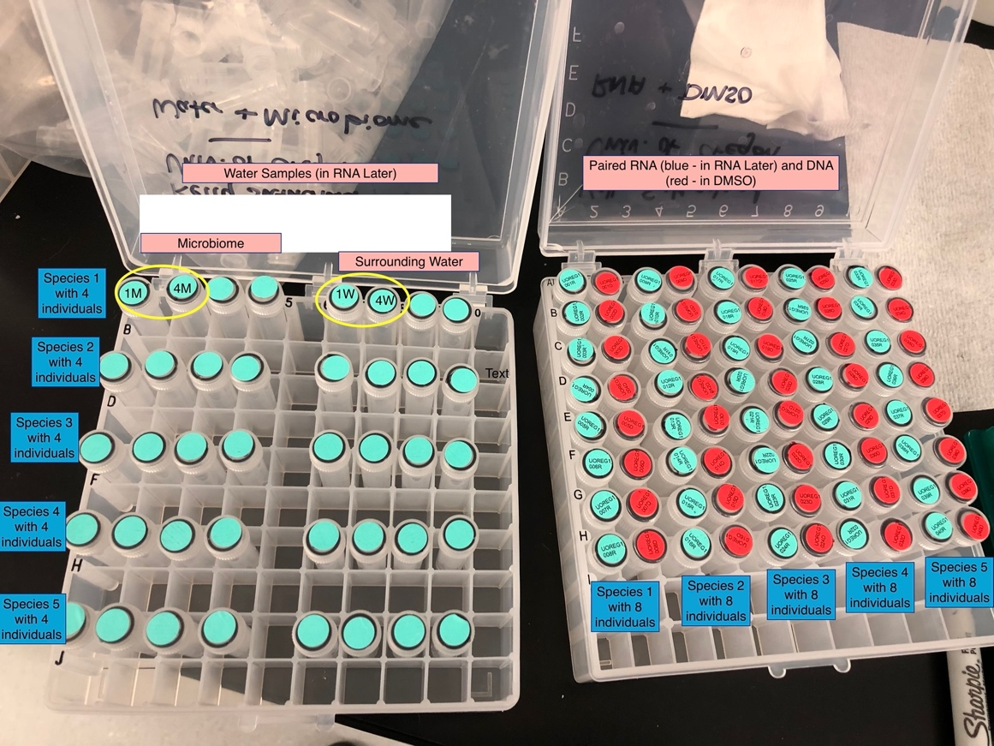

2.2.4. Sampling & storage – Whole genome sequencing: DMSO+salt
- dissect ~0.1-0.2 ml tissue, drop into DMSO+salt in replicate tubes*
- invert tube a few times, make sure the sample is immersed
- place in a freezer (-20C) until shipping (refrigerator ok if no freezer)
- NB: ensure excess water does not dilute the preservative in the tube; try as best possible to put only tissue that is well-drained into the tube.

2.2.5. Sampling & storage – RNA sequencing: RNAlater
- dissect ~0.1-0.2 ml tissue, drop into RNAlater solution in replicate tubes*
- invert tube a few times, make sure the sample is immersed
- store in REFRIGERATOR (not freezer) overnight (~12-24 hours)
- then place in a freezer (-20C) until shipping
- NB: ensure excess water does not dilute the preservative in the tube; try as best possible to put only tissue that is well-drained into the tube.
Sampling & storage – Voucher specimens: (for morphology) – how best to preserve other things
– acoels: acidic 2.5% (v/v) glutaraldehyde in sea water
https://www.biotaxa.org/Zootaxa/article/download/zootaxa.1008.1.1/23496
– ctenophores: acidic Lugol’s solution https://academic.oup.com/plankt/article/31/8/917/1489363?login=false
– medusae: preserve in 4% formalin in seawater
– pyrosomes: preserve in 4% formalin in seawater
– all: deposit with a local museum that supports international loans

3. SHIPPING SAMPLES
Reference Genome Samples
Contact the ASG team and Biocair to arrange shipment.
– include copies of all permits: CITES, IV58, e-Dec, export permit, research permits under which specimens were collected, any additional local permits.
– Pack samples in provided Polar Tech box and/or additional envelopes
– Include at least 4 lbs / 2 kg of dry ice (or equivalent)
– Use designated ‘cold chain courier’ i.e. Biocair via sangertol@biocair.com
Remaining Samples (WGS, RNA, Water)
Contact Mike and Karly to coordinate shipment.

We have provided return shipping envelopes that will hold one tube box per envelope. When ready ask us for a printable label to affix on shipping envelope.
– include copies of all permits: CITES, IV58, e-Dec, export permit, research permits under which specimens were collected, any additional local permits.
University of California, Merced
Facilities Services Building A
FAO: Dr. Michael Dawson, SRE-252
5200 North Lake Road
Merced, CA 95343,
USA
4. ACID WASH PROTOCOL
Acid wash protocol - 10% HCl acid bath
Procedure Notes:
1. Use the formula (M1)(V1)=(M2)(V2) where M is the molarity (37% concentrated, 10% final) and V is the volume to determine the amount of concentrated hydrochloric acid needed. The amount of water is determined by the amount of HCl plus whatever is needed to bring the solution up to the final desired volume.
2. Always add acid to water
3. All glass/plasticware should be acid washed on the same day that it is used
4. Glass/plasticware should be acid washed in fume hood or well-ventilated area
5. Recommend that if acid wash tub is large that it be put up on blocks to improve air flow around the tub in the fume hood

Procedure Steps:
1. Don lab coat, lab apron, safety goggles, and gloves
2. Place the acid bath tub in fume hood and fill with XX L of double distilled RO or deionized water
3. Carefully pour concentrated HCl into graduated cylinder to XX L/mL (10% final concentration)
4. Slowly pour hydrochloric acid into the water, watch for dripping on outside of cylinder
5. Mix thoroughly with stir rod and place lid on acid bath tub if not being used immediately
6. Fill rinse tub with deionized water and place in fume hood
7. Place filter chambers and syringes to be washed in tub and transport to fume hood
8. Place filter chambers and syringes in acid bath making sure to completely immerse all items in acid solution. Leave to soak for 30 minutes.
9. Rinse transport tub with deionized water
10. Drain filter chambers and syringes back into the acid bath and transfer to the rinse tub making sure that all items are completely immersed in rinse water
11. Drain filter chambers and syringes back into acid bath and place in transport tub
12. Rinse filter chambers and syringes with RO water a minimum of 6 times
13. Place washed items on drying rack (make sure items are inverted)
14. Check pH of water in rinse tub and neutralize with sodium bicarbonate, sodium hydroxide or acid neutralizer to a pH of 5-8 before disposing down drain

5. PARTS LIST
A list of parts for filtering equipment

Description | Link | Cat#
BD Syringes without Needle, 50 mL | https://www.fishersci.com/shop/products/bd-syringes-luer-lok-tips-4/136898 | 13-689-8
Durapore® Membrane Filter, 0.22 µm | https://www.sigmaaldrich.com/US/en/product/mm/gvwp04700 | GVWP04700
Cole-Parmer Polypropylene Filter Holder for 47 mm Membranes; 10/Pk | https://www.amazon.com/Cole-Parmer-Polypropylene-Filter-Holder-Membranes/dp/B07WTBR8X4/ref=sr_1_3?keywords=cole-parmer+polypropylene+filter+holder+for+47mm+membrane&qid=1649090793&sprefix=Cole-parmer+polyp%2Caps%2C141&sr=8-3 | AO-06623-52

6. WHAT IF …
… I don’t have access to liquid nitrogen or dry ice?
> Partners who cannot access LN2 and dry ice are using DMSO as the preservation solution. There has been some success with this in the sequencing pipeline, however flash-freezing if possible, is preferred.

… my organisms are tiny, gelatinous, without cell-rich parts, with a food-rich gut when caught?
> Starve the animals where possible (overnight or similar) and then dissect including the gut. If the gut is easily removed from the animals, do remove it, however if not, we would prefer good quality tissue with gut (preferably empty gut) rather than tissue which has been compromised by trying to remove the gut.

… I’m sampling a benthic organism, such as an anemone?
> All steps are the same except Section 2.2.3(b) for sampling the host-associated water. Instead, we can provide Q-tips for swabbing the host epidermis, which can then be dropped into the tube of liquid preservative (using scissors to cut the stem below where you’ve been holding so that contamination is not introduced). When swabbing, be sure to press the Q-tip firmly against the epidermis and rotate the stick between your finger and thumb, while also moving it in small circles across the surface of the animal for about 5 seconds; repeat in a second position. Keep a note of which part(s) of the body you sampled.

